|  |  |
| --- | --- |
| **Student Name:** |  |
| **Student ID:** |  |
| **Task Title:** | **Portfolio Part 1: Project Kick-off** |
| **Task Number:** | **1** |
| **Task Code:** | **ICTPRG401-ICTPRG413-POR-P1** |
| **Due Date:** | *Please see blackboard for the most accurate due date.* |
| **Notes:** | *If you did not DOUBLE CLICK this template, then close the file and do so to create your blank report.*  *Make sure you go to* Appendix 1: Template Instructions *and read these instructions carefully before using this template.*  *If a question is marked as, e.g., A1 or B3, then either “intern A”* ***or*** *“intern B” answers that question.*  *Any question marked as 02 should be answered by* ***both*** *interns.* |

Table of Contents

A1 Prepare a repository 3

A2 Add Open-Source license 3

A3 Add README 3

B1 Fork A’s Public Repository 3

B2 Make changes inside branch 3

B3 Create Pull Request (PR) 3

References 3

Appendix 1: Template Instructions 3

Updating Table of Contents 3

Adding References 3

Updating References 3

Before Submitting the Assessment 3

# A1 Prepare a repository

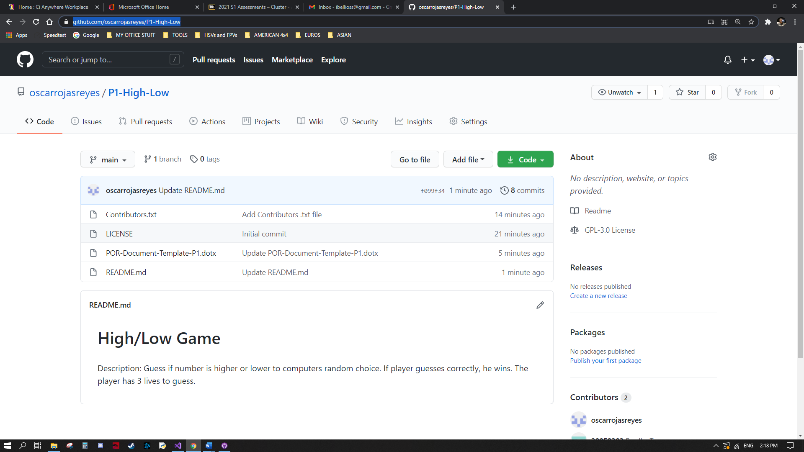

https://github.com/oscarrojasreyes/P1-High-Low

# A2 Add Open-Source license

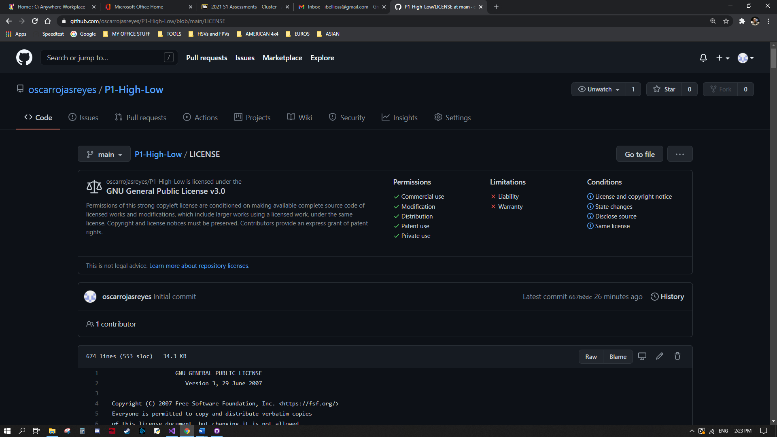

<https://github.com/oscarrojasreyes/P1-High-Low/blob/main/LICENSE>

This was a random choice of license; I am not familiar with the difference between licenses. However, this license came up as a recommended amongst others.

# A3 Add README

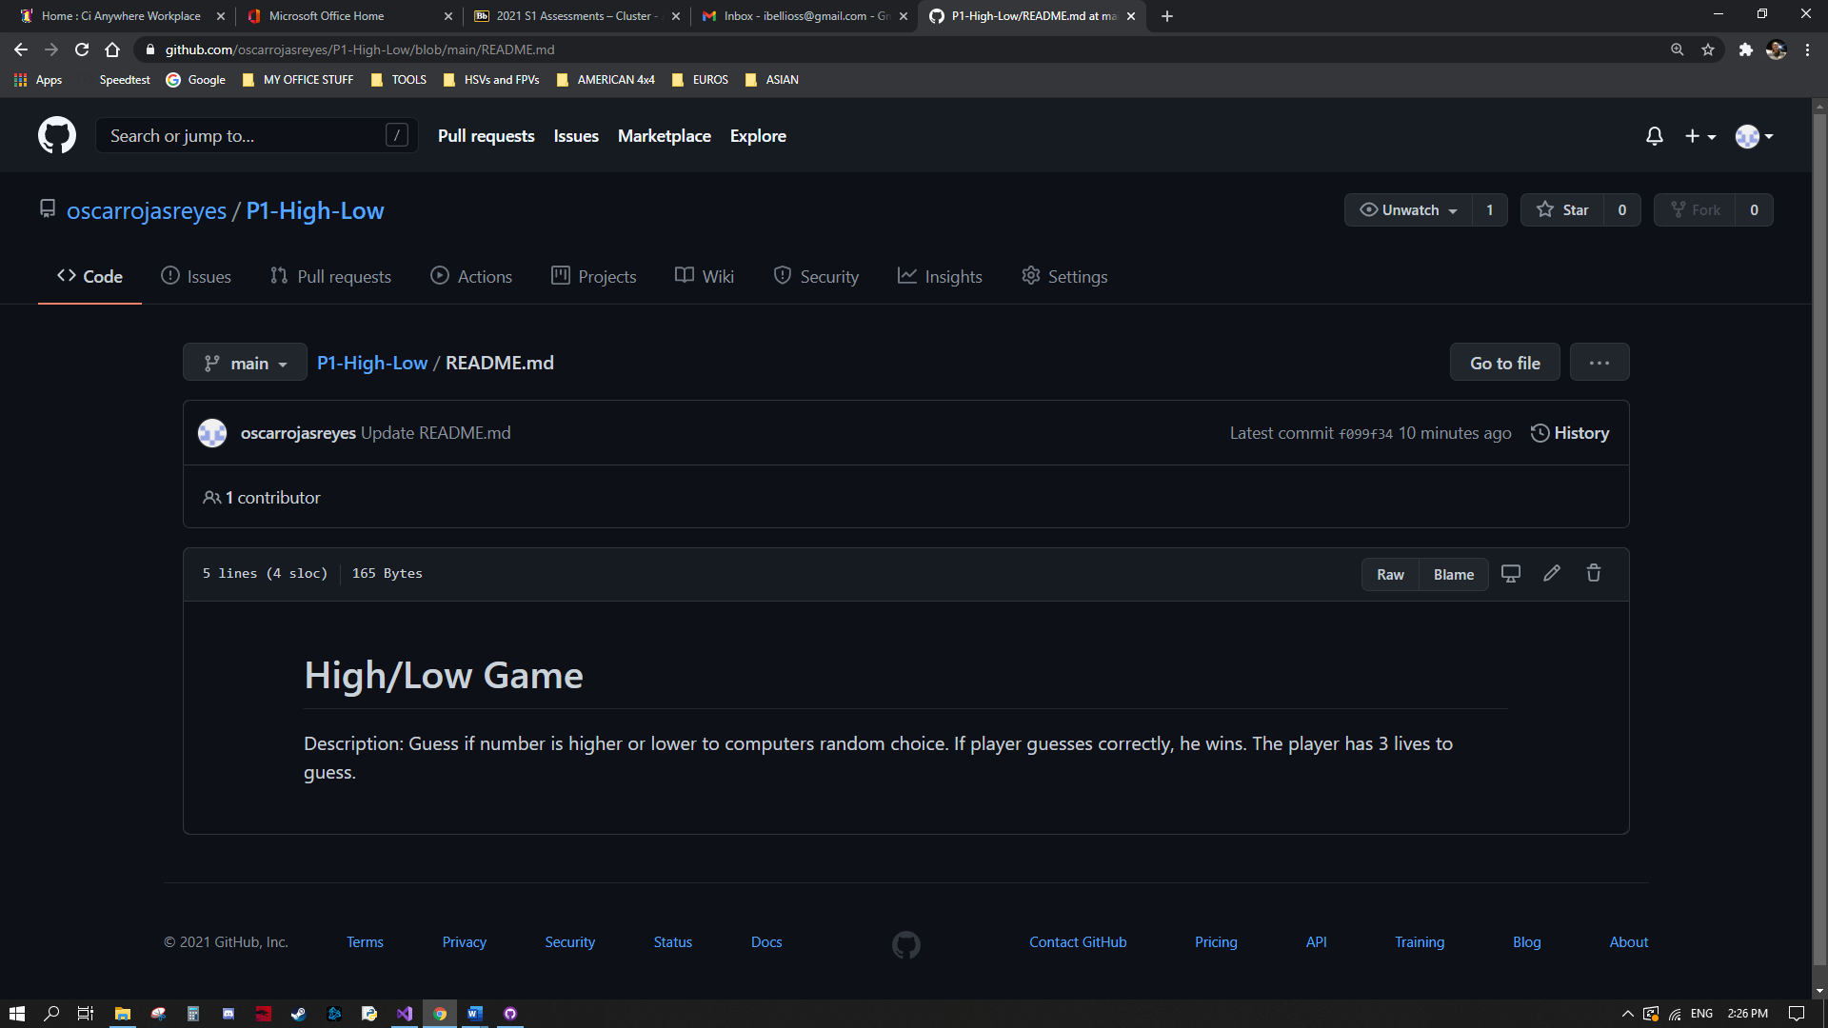

<https://github.com/oscarrojasreyes/P1-High-Low/blob/main/README.md>

Brief explanation of the game.

# B1 Fork A’s Public Repository

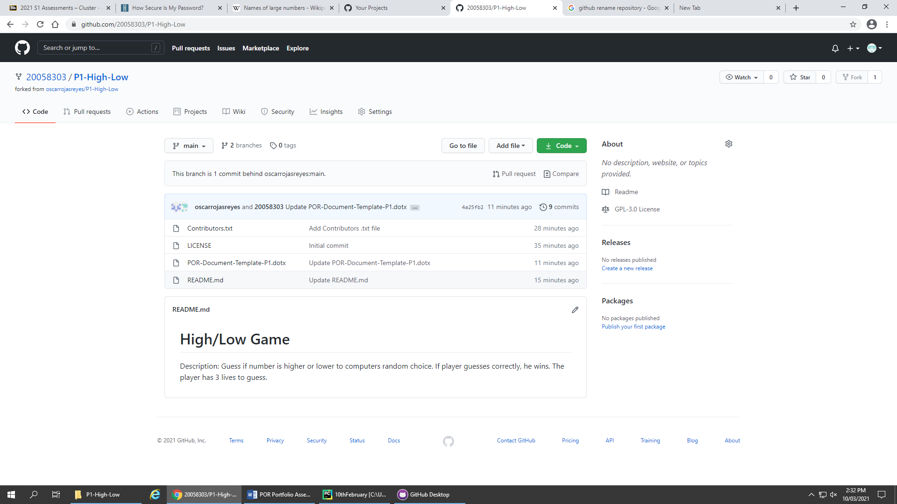

# B2 Make changes inside branch

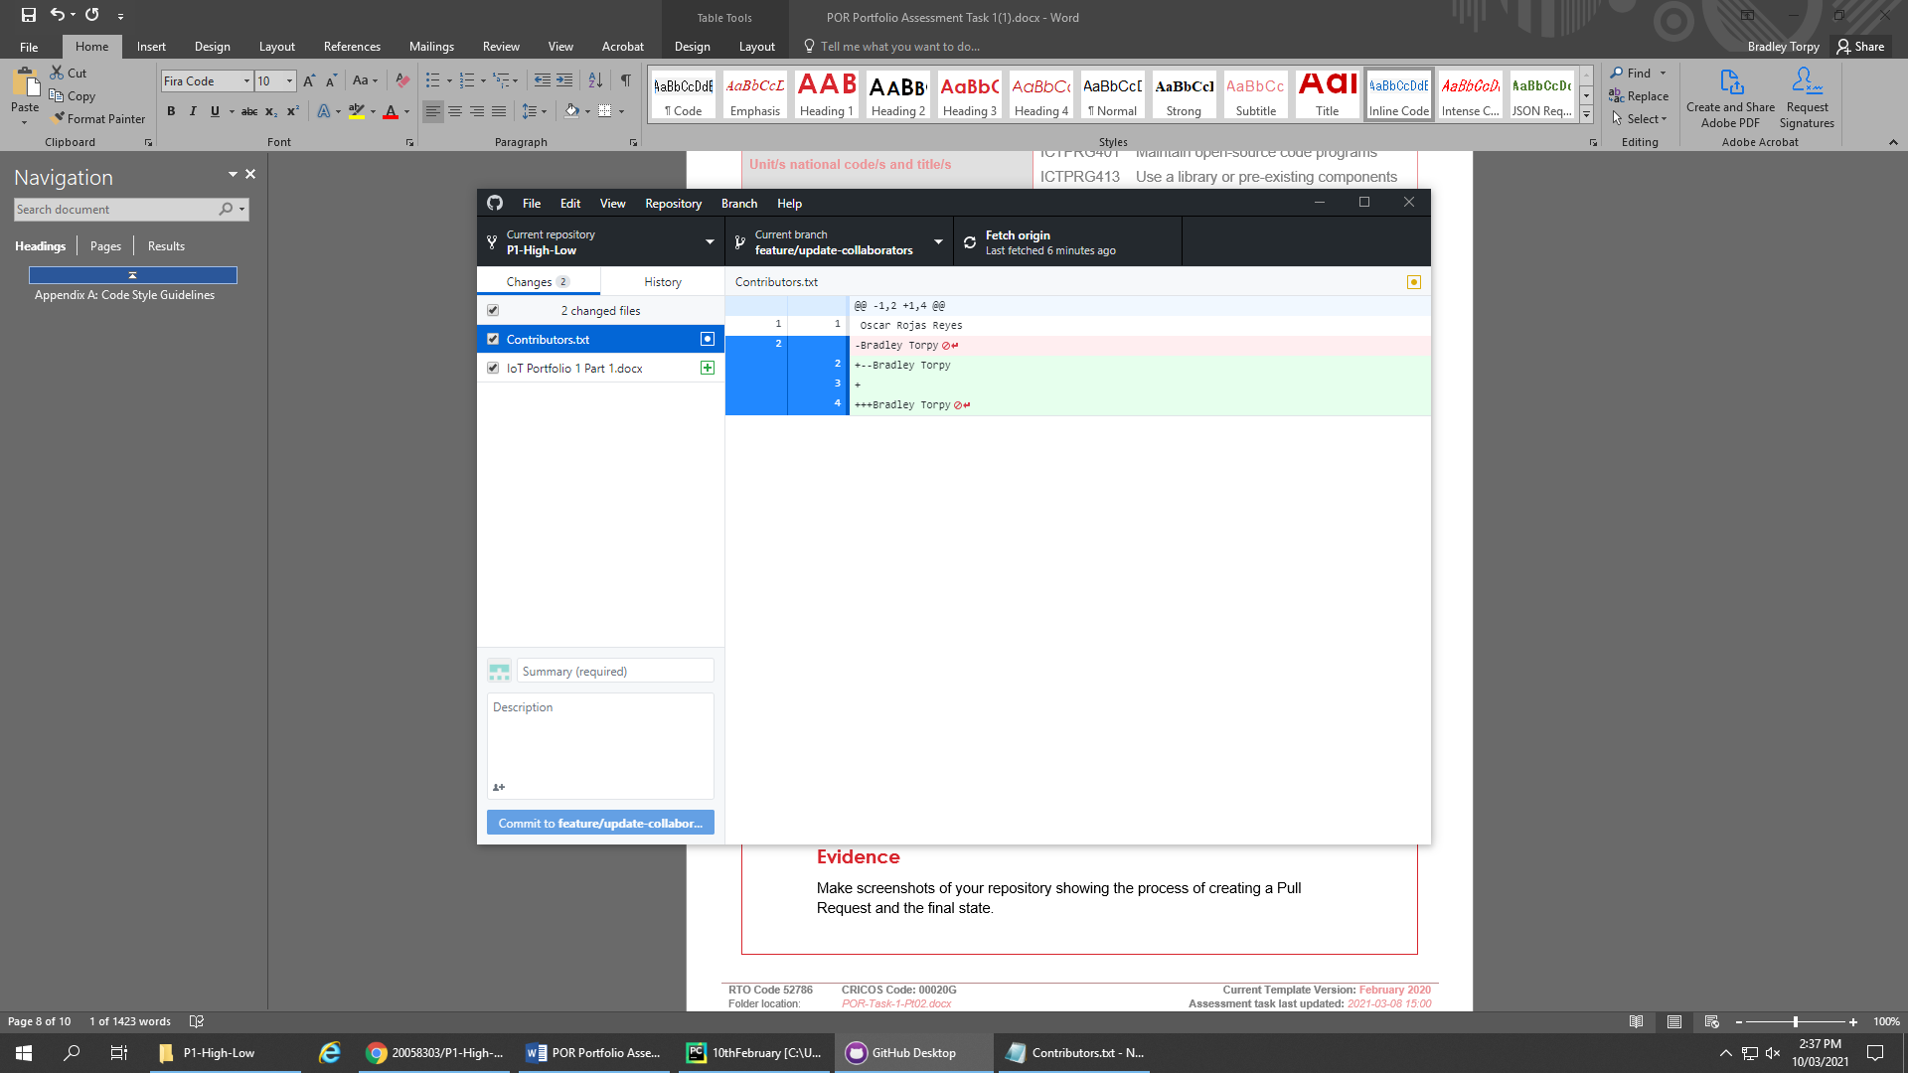

# B3 Create Pull Request (PR)

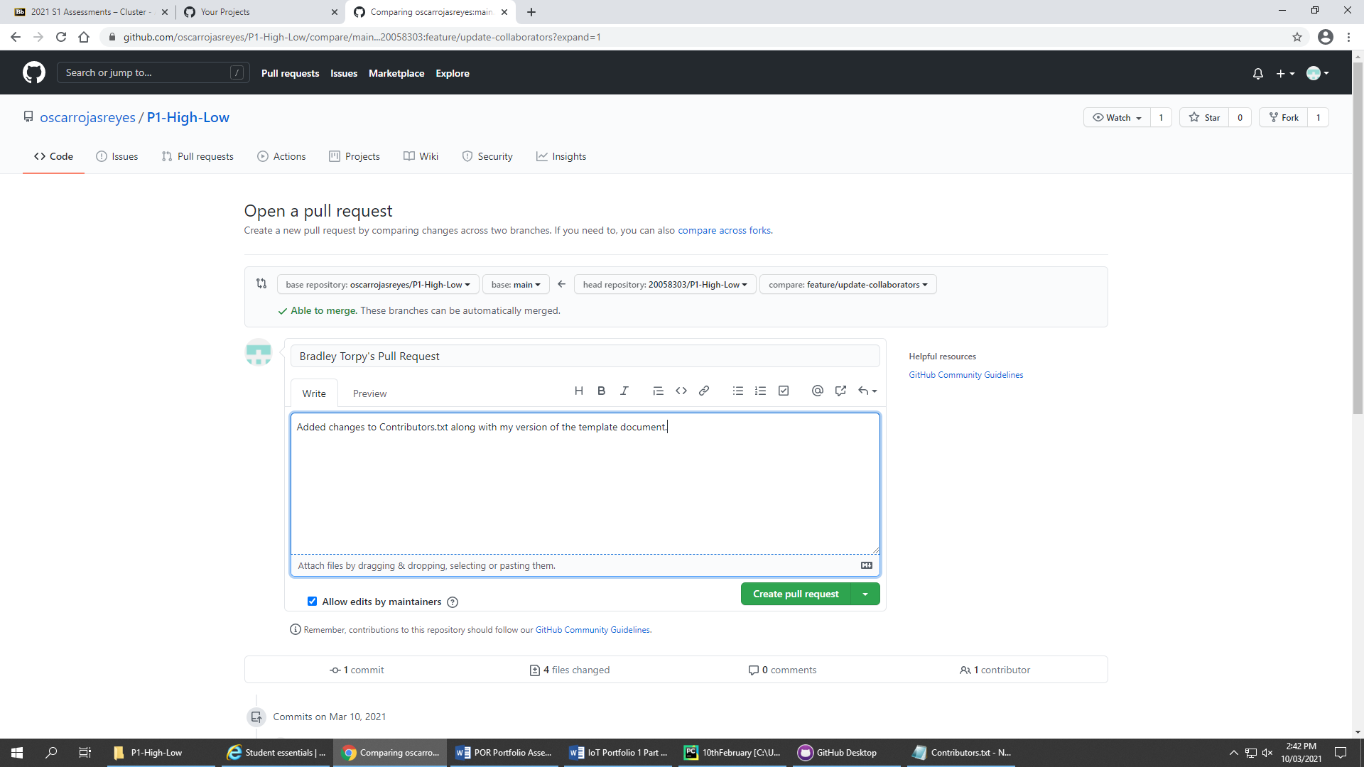

# References

**There are no sources in the current document.**

# Appendix 1: Template Instructions

Some basic instructions on using this template.

These instructions include:

* Adding references, and
* What to do **before** submitting the assessment.

## Updating Table of Contents

To update the table of contents, follow these instructions.

1. Go to second page, this has the table of contents.
2. Click on the Table of Contents heading.
3. At the top click “Update Table”
4. When it asks, click update the whole table.

## Adding References

To add a reference (for example, a supplier) use the built in referencing capability of Word.

1. Click on References (Menu),
2. Click Manage Sources,
3. Click New,
4. Click Show all bibliography fields,
5. Select Type of Source to be “Web Site”,
6. In the dialog you **must** add at least the:
   * Author (Company name, using the Corporate Author checkbox),
   * Name of the Web page,
   * Name of the web site,
   * Year (This can be the current year),
   * URL.
7. Click OK.
8. Repeat above steps as needed.
9. Click Close when done.

Once done, remember to update the references.

## Updating References

This will update the references with any references / citations you have added using previous steps.

1. Go to the last page in the document
2. Click on the References heading.
3. At the top, click on the “Update Citations and Bibliography”.

## Before Submitting the Assessment

Before you submit the assessment:

1. Ensure you have completed all the steps and answered all questions in the assessment task.
2. Update Table of Contents
3. Update the References
4. Save this document as per instructions in the assessment task.
5. Export the document to a PDF as per the instructions to the assessment task.
6. Upload both documents to the Learning Management System (Blackboard) as per instructions in the assessment task.